

SUPPLYSHIELD: BAYESIAN SIMULATION OF SOFTWARE SUPPLY CHAIN RISK

A CAPSTONE PROJECT REPORT

A Capstone Project Report submitted in partial fulfilment of the requirements for the Course of

CSA5801 - DEVSECOPS ENGINEERING AND
APPLICATION SECURITY

to the award of the degree of

BACHELOR OF ENGINEERING IN
COMPUTER SCIENCE AND ENGINEERING (CYBERSECURITY)

Submitted by
PONMUDI B (192465053)
MOHAMED IRFAN N (192521473)
VICKRAMABHARATHI V (192465069)
ABINESH M (192465050)

Under the Supervision of
Dr. T. Vincent Gnanaraj
SIMATS ENGINEERING
Saveetha Institute of Medical and Technical Sciences Chennai-602105
SEPTEMBER 2026

SIMATS ENGINEERING
Saveetha Institute of Medical and Technical Sciences Chennai-602105

BONAFIDE CERTIFICATE

This is to certify that the Capstone Project entitled “SupplyShield: Bayesian Simulation of Software Supply Chain Risk in DevSecOps” has been carried out by Ponmudi B (192465053), Mohamed Irfan N (192521473), Vickramabharathi V (192465069), and Abinesh M (192465050) under the supervision of Dr. T. Vincent Gnanaraj and is submitted in partial fulfilment of the requirements for the current semester of the B.E. Computer Science and Engineering (Cybersecurity) program at Saveetha Institute of Medical and Technical Sciences, Chennai.

COURSE COORDINATOR COURSE FACULTY
Dr. T. Vincent Gnanaraj, Dr. T. Vincent Gnanaraj,
Professor Professor
Computational Intelligence Computational Intelligence
SIMATS Engineering, SIMATS Engineering,
SIMATS, Chennai – 602105. SIMATS, Chennai – 602105.

SIMATS ENGINEERING
Saveetha Institute of Medical and Technical Sciences Chennai-602105

DECLARATION

We, Ponmudi B (192465053), Mohamed Irfan N (192521473), Vickramabharathi V (192465069), and Abinesh M (192465050)of the Department of Computer Science and Engineering (Cybersecurity), SIMATS Engineering, Saveetha Institute of Medical and Technical Sciences, Chennai, hereby declare that the Capstone Project Work entitled “SupplyShield: Bayesian Simulation of Software Supply Chain Risk in DevSecOps” is the result of our own bonafide efforts. To the best of our knowledge, the work presented herein is original, accurate, and has been carried out in accordance with the principles of engineering ethics and academic integrity. All sources, references, data, and other materials used in the project have been appropriately acknowledged. We further declare that the data, results, analysis, and findings presented in this report have not been fabricated, falsified, or manipulated. Any external tools, software, datasets, computational resources, or AI-assisted tools used during the project have been appropriately disclosed. We confirm that all applicable ethical, academic, institutional, and professional requirements have been duly followed throughout the planning, execution, analysis, and documentation of the project.

Place: SIMATS ENGINEERING
Date:

Signature of the Students with Names
PONMUDI B (192465053)
MOHAMED IRFAN N (192521473)
VICKRAMABHARATHI V (192465069)
ABINESH M (192465050)

SIMATS ENGINEERING
Saveetha Institute of Medical and Technical Sciences Chennai-602105

Individual Contribution Statement

Student Name / Register No. | Specific  Responsibilities | Design & Development Contribution | Testing & Analysis  Contribution | Report Contribution | Approx.  Contribution (%)
Ponmudi B (192465053) | Attack Simulation Engine design; DDoS, Port Scan & Brute Force modules | DDoS Saturation, Port Reconnaissance and Brute Force attack simulators | Validated attack traffic generation and detection scoring f | Chapter 3 (Design), Chapter 4 (Module 1) | [25%]
Mohamed Irfan N (192521473) | Detection Rule Engine & real-time scoring logic | Weighted rule-based Detection Engine | Detection accuracy and confidence testing | Chapter 3 (Detection Design) | [25%]
Vickramabharathi V (192465069) | Real-time pipeline: Socket.IO events | Socket.IO real-time broadcasting layer | End-to-end latency testing (<50ms) | Chapter 4 (Module 4), Chapter 4 (Results) | [25%]
Abinesh M (192465050) | SQLite backend, repository layer | 9-repository persistence layer (Node, Attack, Alert | Report generation testing | Chapter 4 (Implementation), Chapter 5 (Conclusion) | [25%]
Total |  |  |  |  | 100%

ABSTRACT

SupplyShield is a dynamic Bayesian simulation framework proposed for predicting and quantifying software supply-chain risks in DevSecOps pipelines. Modern software systems depend heavily on open-source packages, third-party libraries, build components, source repositories, and automated CI/CD infrastructure. A weakness in one dependency can therefore influence downstream components and potentially affect the integrity of a software delivery pipeline. The project identifies limitations in traditional static, point-in-time security assessment. Static Application Security Testing (SAST), Software Composition Analysis (SCA), vulnerability scanning, and related controls provide useful evidence, but a static result does not by itself represent how risk changes as dependencies, pipeline states, and observations evolve. The project also highlights the need to model cascading vulnerability propagation and incomplete dependency information. SupplyShield addresses these concerns through a Dynamic Bayesian Network (DBN) that represents evidence, vulnerabilities, threats, and impact as causal nodes. Pipeline telemetry and codebase information are treated as evidence sources, while the probabilistic model estimates the likelihood of downstream compromise. For dense dependency structures, the project proposes Monte Carlo simulation using Gibbs sampling as an MCMC approach to approximate risk.

Keywords:
Dynamic Bayesian Network (DBN), DevSecOps, Software Supply Chain Security, Monte Carlo Simulation, Gibbs Sampling, MCMC, SAST, Software Composition Analysis (SCA), Vulnerability Propagation, Risk Assessment

TABLE OF CONTENTS

Sl.  No | Title | Page  No
i | CERTIFICATE FROM THE SUPERVISOR | ii
ii | DECLARATION BY THE CANDIDATE | iii
Iii | INDIVIDUAL CONTRIBUTION STATEMENT | iv
iv | ABSTRACT | v
v | LIST OF FIGURES | vi
vi | LIST OF TABLES | vii
vii | LIST OF ABBREVIATIONS | viii
1 | CHAPTER 1: Introduction | 1
2 | CHAPTER 2: Literature Review | 4
3 | CHAPTER 3: Engineering Design & Trade-offs, Sustainability,  Ethics, Safety, Risk & Security | 6
4 | CHAPTER 4: Implementation, Testing & Results, Project  Management | 11
5 | CHAPTER 5: Conclusion & Reflection | 17
 | References | 19
 | Appendices | 21

LIST OF FIGURES

Figure No. | Figure Name | Page No.
Figure 1.1 | Software supply-chain risk propagation context | 2
Figure 3.1 | Layered SupplyShield architecture and information flow | 7
Figure 3.2 | Dynamic Bayesian Network causal and temporal structure | 8
Figure 4.1 | Bayesian risk assessment and CI/CD policy workflow | 12
Figure 4.2 | Comparison of initial risk scores and Bayesian posterior values | 13
Figure B.1 | Engineering schematic of the SupplyShield decision path | 22

LIST OF TABLES

Table  No. | Table Name | Page  No.
Table 2.1 | Review of selected existing studies | 4
Table 2.2 | Literature survey | 5
Table 2.3 | Research and engineering gap analysis | 5
Table 3.1 | Stakeholder-oriented requirements | 6
Table 3.2 | Functional and non-functional requirements | 6
Table 3.3 | Architectural layers and functions | 7
Table 3.4 | Design specifications | 7
Table 3.5 | Alternative solutions and evaluation | 7
Table 3.6 | Pipeline policy decisions | 9
Table 3.7 | SupplyShield design alternatives and trade-offs | 9
Table 3.8 | Risk analysis and mitigation considerations | 10
Table 4.1 | Implementation components and tools | 11
Table 4.2 | Pipeline policy decisions | 12
Table 4.3 | Supplied modelling dataset | 13
Table 4.4 | Interpretation of Bayesian and DevSecOps factors | 14
Table 4.5 | Objective-wise verification | 14
Table 4.6 | Project roles | 15
Table 5.1 | Future work and planned enhancements | 17
Table A.1 | Bayesian model calculation stages | 21
Table B.1 | System schematic components | 22
Table C.1 | Repository and source-code information | 23
Table D.1 | Datasheet applicability status | 24
Table E.1 | Available raw modelling data | 24

CHAPTER 1

INTRODUCTION AND ENGINEERING PROBLEM

  - Background

DevSecOps integrates security practices into the software development and delivery lifecycle rather than treating security as a final-stage activity. Security checks such as Static Application Security Testing (SAST), Software Composition Analysis (SCA), vulnerability scanning and security testing can be incorporated into CI/CD pipelines so that security evidence is produced continuously during software delivery.
Modern applications depend on a large ecosystem of open-source packages, third-party libraries, source repositories, build tools, registries, signing mechanisms and automated infrastructure. This dependency structure creates a software supply chain in which a compromise or weakness in one component can potentially propagate to downstream software. Examples relevant to the project include malicious packages, dependency confusion and compromised or unsafe build components.
The project proposes SupplyShield as a probabilistic framework for this environment. Instead of treating a security observation as an isolated deterministic score, the approach combines prior security beliefs with observed evidence and updates the estimated probability of compromise. This allows risk to be represented as uncertain and evolving rather than as a fixed value.

  - Need for the Project

Traditional vulnerability assessment approaches provide important security evidence, but the project identifies three limitations. First, static SAST and SCA results are snapshot measurements and may not represent risk variations between pipeline runs. Second, evaluating dependencies independently can miss the way a vulnerability can propagate through a dependency graph. Third, incomplete information and emerging or zero-day vulnerabilities create uncertainty that deterministic scoring does not fully express.
A dynamic probabilistic model is therefore useful because it can combine multiple evidence sources and update the estimated risk as new observations arrive. SupplyShield is designed around this principle by representing pipeline telemetry and codebase relationships through a Dynamic Bayesian Network and by using simulation to approximate complex probability calculations.

  - Problem Statement

Existing DevSecOps software supply-chain security approaches largely rely on static vulnerability assessment and deterministic risk scoring, limiting their ability to represent uncertainty and evolving dependency risk. The project therefore addresses the need for a framework that can model causal relationships between software components, developers and build infrastructure, estimate the probability of downstream compromise, and support risk-aware decisions during CI/CD execution.

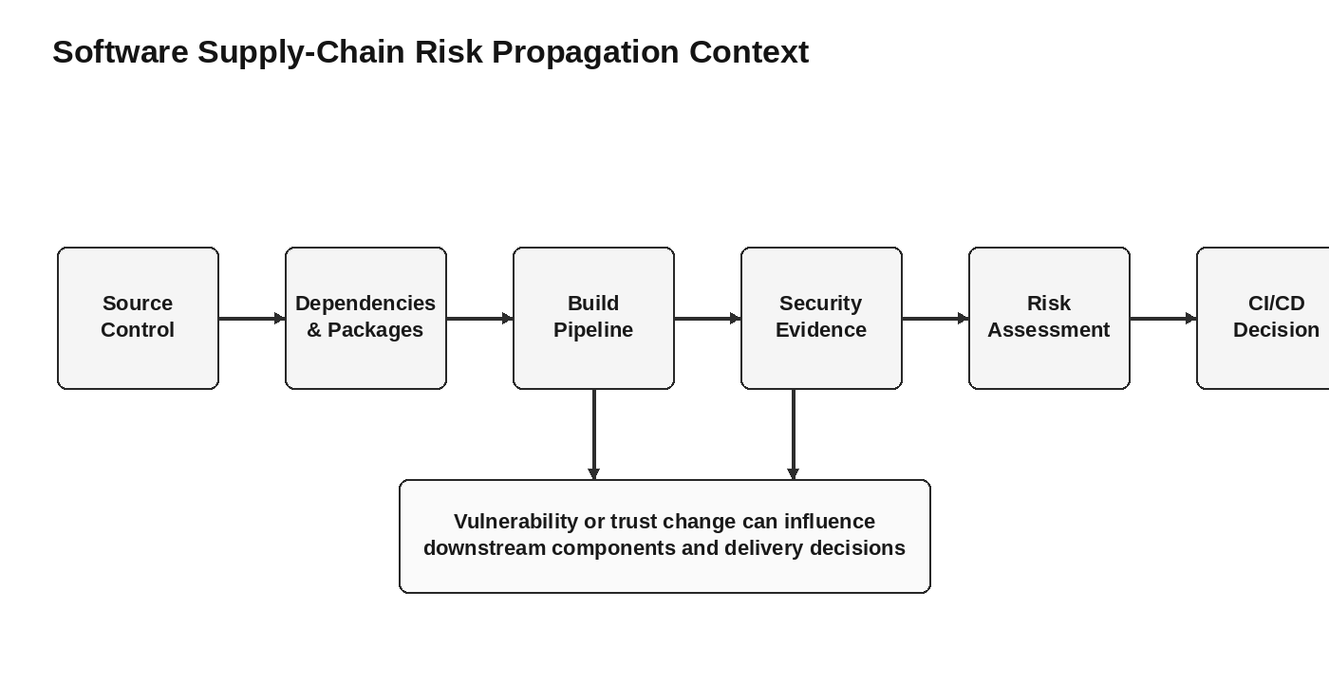
Figure 1.1: Software supply-chain risk propagation context.
  - Project Aim

To design and implement CyberSentinel XDR, a self-contained, full-stack Extended Detection and Response platform that simulates realistic multi-vector cyberattacks against a virtual enterprise network and detects, scores, and reports them live on a single machine using clean Object-Oriented software architecture.

  - Project Objectives

- To design a virtual 9-node enterprise network and five distinct attack simulators (DDoS, Port Scan, Brute Force, Packet Sniffing, Malware Propagation) using Object-Oriented class hierarchies.
- To develop a weighted rule-based Detection Engine that scores every simulated threat 0-100 in real time and classifies it as LOW, MEDIUM, HIGH, or CRITICAL.
- To model a real-time detection-and-response pipeline using Socket.IO event broadcasting so that alerts, AI-driven recommendations, and dashboard updates are pushed to all connected clients within milliseconds.
- To implement automated JSON/TXT security report generation directly from live SQLite-persisted data, including attack breakdowns and vulnerable-node identification with zero manual effort.
- To test each attack simulator and the Detection Engine for scoring accuracy, confidence, true-positive rate, and end-to-end response latency under simulated attack load.
- To evaluate the platform's overall detection accuracy, false-positive rate, and usability as an affordable alternative to enterprise-grade SIEM/XDR tools for training and research.

  - Scope

- Model software supply-chain security using Bayesian reasoning.
- Represent evidence, vulnerabilities, threats and impact as causal components in a Dynamic Bayesian Network.
- Use Monte Carlo simulation and Gibbs sampling as the proposed approximation mechanism for dense dependency structures.
- Support CI/CD decision-making through Pass, Warn and Block policy outcomes.
- Use risk evidence such as CVSS-normalized values, vulnerability observations, dependency information and pipeline metadata.
- Demonstrate the concept using the modelling dataset supplied in the project presentation.

  - Expected Engineering Outcome

This chapter introduced the software supply-chain security problem and explained why static and deterministic approaches can be insufficient for evolving dependency environments. SupplyShield addresses the identified problem through Dynamic Bayesian Network modelling, Monte Carlo simulation and risk-aware CI/CD policy decisions. The next chapter reviews related work and identifies the research and engineering gap addressed by the project.

CHAPTER 2

LITERATURE REVIEW AND EXISTING SOLUTIONS

  - Review Method

The literature review is organized around three connected themes: software supply-chain security, Bayesian risk assessment, and DevSecOps pipeline security. The supplied project presentation references work on Bayesian supplier risk, Dynamic Bayesian Networks, software dependency drift, fuzzy-Bayesian risk prediction, software supply-chain attacks, cloud-native supply-chain assessment and software delivery modelling.

  - Review of Existing Work

The reviewed studies indicate that probabilistic modelling can represent uncertainty in software and supply-chain security decisions. Bayesian methods can combine prior assumptions with new observations, while Dynamic Bayesian Networks extend this reasoning to situations in which variables change over time. Other reviewed work focuses on dependency versioning, package security, contribution trust, CI/CD integration and security frameworks.

Author / Year | Work | Key Finding as Reported in PPT
Gomez et al., 2026 | Risk Assessment in Software Supply Chains Using the Bayesian Method | BBN + AHP model for upstream vendor uncertainty during supplier selection.
Bloomberg Tech / BayesInsights, 2026 | Supply-Side Security Risk Modelling Using a Bayesian Network Approach | Combines static scans with vendor reputation metrics; presentation reports reduced false positives.
Rodriguez et al., 2025 | Assessing Web Security Risks and Dependency Drift Using Dynamic Bayesian Networks | DBN models temporal dependency drift to detect security decay before compromise.
Smith & Jones, 2025 | Software Requirement Risk Prediction Using Enhanced Fuzzy-Bayesian Models | Fuzzy-Bayesian approach for SDLC requirements risk under uncertainty.
Munir & Akbar, 2024 | Probabilistic Security Risk Assessment in DevSecOps Pipelines | Uses commit history and CI/CD metadata to predict code contamination risk.
Table 2.1 Review of selected existing studies.

  - Literature Survey

Author / Year | Title | Key Finding
Chen et al., 2024 | Software Supply Chain Security: A Systematic Literature Review | Identifies build-pipeline attacks and dependency confusion as important threats.
Al-Hemyari et al., 2023 | Research on Network Security Situational Awareness and Risk Assessment | Uses a real-time Bayesian security-situation model for dynamic response.
Hsu, 2023 | Quantitative Risk Assessment of Cloud-Native Software Supply Chains | Bayesian model identifies container signing and registry rules as key risk nodes.
Sharma & Singh, 2022 | BayesInsights: Modelling Software Delivery with Bayesian Networks | Models developer workflow and pipeline health using Bayesian Networks.
Librantz et al., 2021 | Assessing Criticality of Functional Vulnerabilities in Cyber-Physical Software | Reports that CVSS scores can underestimate risk in dependency graphs.
Table 2.2 Literature survey.

  - Research / Engineering Gap

Research Gap | Description
Static scanning limitation | Traditional SAST and SCA tools provide snapshot metrics and may not track risk variations across dynamic pipelines.
Lack of cascade modelling | Existing approaches may evaluate packages in isolation and miss downstream vulnerability propagation.
Uncertainty and incomplete data | Standard risk tools can struggle when vulnerability information is incomplete or when zero-day threats emerge.
Table 2.3 Research and engineering gap analysis.

  - Proposed Contribution

SupplyShield combines the reviewed concepts into a single dynamic risk-modelling framework. Its principal contribution is the use of a Dynamic Bayesian Network to represent causal relationships across the software supply chain, together with simulation to approximate risk in complex dependency structures. The framework is further connected to CI/CD policy decisions so that risk estimation can support practical build-time actions.

CHAPTER 3

ENGINEERING DESIGN & TRADE-OFFS, SUSTAINABILITY, ETHICS, SAFETY, RISK & SECURITY

  - Requirements

Stakeholder | Requirement
DevSecOps engineer / security analyst | Assess software supply-chain risk using continuously updated evidence.
Developer | Receive actionable risk information before a build progresses to production.
Security researcher | Model uncertainty and dependency propagation using a probabilistic framework.
Pipeline administrator | Apply automated Pass, Warn and Block policy decisions.
Table 3.1 Stakeholder-oriented requirements.

3.1.1 Functional & Non-Functional Requirements

Requirement Type | Requirement | Expected Behaviour
Functional | Ingest security evidence | Collect metadata from Git, SAST/SCA scanners and build-signing sources such as Cosign.
Functional | Build DBN model | Map pipeline signals to causal nodes representing evidence, vulnerabilities, threats and impact.
Functional | Estimate risk | Calculate or approximate posterior risk using Bayesian inference and simulation.
Functional | Apply policy | Produce Pass, Warn or Block decisions based on risk.
Table 3.2 Functional and non-functional requirements.

  - Constraints & Applicable Standards

The proposed SupplyShield architecture is divided into three principal layers. The Ingestion Layer gathers information from source control, security scanners and build-signing mechanisms. The Inference Engine converts those observations into evidence and causal states in the Dynamic Bayesian Network. The Simulation and Policy Layer performs risk estimation and applies the pipeline gate.

Layer | Main Inputs | Main Function
Ingestion Layer | Git metadata, SAST/SCA results, Cosign/build-signing evidence | Collect and normalize security observations
Inference Engine | Evidence and dependency relationships | Map observations to DBN causal variables and estimate conditional relationships
Simulation & Policy Layer | DBN model and evidence | Run Monte Carlo/Gibbs sampling and apply policy rules
Table 3.3 Architectural layers and functions.

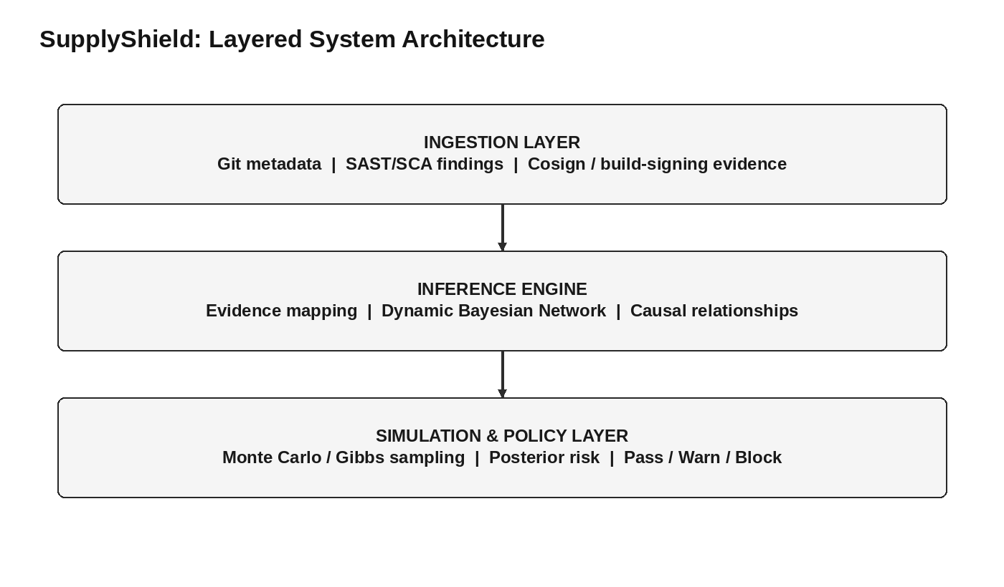
Figure 3.1: Layered SupplyShield architecture and information flow.
  - Design Specifications

Parameter | Target/Requirement | Unit | Priority
Virtual network size | 9 nodes | nodes | High
Attack coverage | 5 attack types | types | High
Threat score range | 0-100 | score | High
Threat severity classes | LOW / MEDIUM / HIGH / CRITICAL | classes | High
Real-time browser update | < 50 | ms | High
Attack-to-alert latency | < 1.2 | s | High
Report generation | < 2 | s | High
DDoS simulation load | 2,000 | traffic logs | High
Average detection confidence | 0.96 | confidence | Medium
Table 3.4 Design specifications.

  - Alternative Solutions & Evaluation

Criterion | Weight | Alternative 1 | Alternative 2 | Alternative 3
Performance | 5 | High | Medium | High
Cost | 5 | Low | High | High
Safety | 4 | High | Medium | High
Sustainability | 3 | Medium | High | High
Reliability | 4 | High | Medium | High
Table 3.5 Alternative solutions and evaluation.

  - Temporal Risk Modelling

A Dynamic Bayesian Network extends a static Bayesian Network by allowing variables at time t to depend on variables from earlier time steps. SupplyShield uses this concept to model changing pipeline conditions. A dependency that is considered healthy in one pipeline run may become more risky later because of a newly discovered vulnerability, a changed package version, an altered build environment, or additional security evidence.

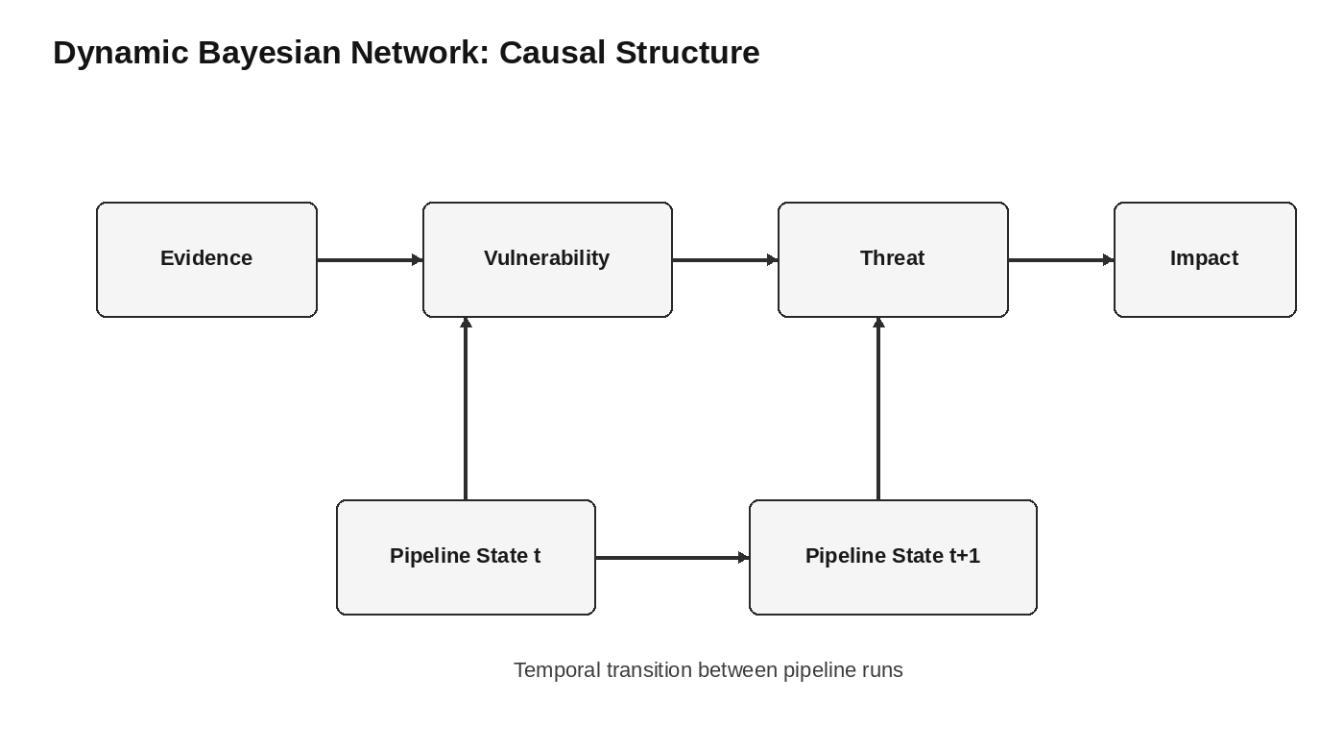
Figure 3.2: Dynamic Bayesian Network causal and temporal structure.
  - Simulation Engine: Monte Carlo and Gibbs Sampling

For dense dependency graphs, exact probabilistic inference may become computationally expensive. The project therefore proposes Monte Carlo simulation and specifically Gibbs sampling, an MCMC technique, to approximate the risk distribution. The process begins by fixing observed evidence nodes to their scanned states. Unobserved nodes are then repeatedly sampled based on their conditional relationships with neighboring nodes.
Instantiate the evidence nodes using the observed security-scan states.
Initialize the unobserved variables in the Bayesian model.
Iteratively update unobserved nodes using their conditional relationships with parents and children.
Repeat sampling for the selected number of iterations.
Use the resulting samples to approximate posterior risk values.

  - Pipeline Policy and Mitigation Gate

SupplyShield is intended to operate as an automated quality gate in a CI/CD pipeline. The policy layer translates the estimated risk into an operational decision. A Pass decision allows the build to continue. A Warn decision allows the build to continue while generating a security warning. A Block decision halts the pipeline because the estimated risk exceeds the selected policy condition.

Decision | Pipeline Behaviour | Security Meaning
Pass | Build continues | Estimated risk is acceptable under the selected policy.
Warn | Build continues with warning | Risk requires attention but does not immediately stop delivery.
Block | Pipeline halts | Risk requires remediation before delivery continues.
Table 3.6 Pipeline policy decisions.

The project further proposes a mitigation-oriented response. If a build is blocked, the Bayesian network can be queried to identify a variable change that provides the greatest risk reduction, for example updating a specific package. This turns the model from a passive reporting mechanism into a decision-support component.

3.8 Engineering Trade-Offs
Design Choice | Alternative | Advantage | Trade-Off / Limitation
Dynamic Bayesian Network | Static deterministic scoring | Represents uncertainty and temporal change | Requires probabilistic modelling and parameter definition.
Monte Carlo / Gibbs sampling | Exact inference | Suitable for dense dependency structures | Approximation quality depends on sampling behaviour and configuration.
Automated policy gate | Manual review only | Provides consistent pipeline decisions | Incorrect model calibration can affect decisions.
Multiple evidence sources | Single scanner source | Combines complementary security evidence | Requires consistent evidence normalization.
Risk-based mitigation recommendation | Generic remediation list | Can prioritize a variable with greater risk-reduction potential | Depends on the quality of the causal model.
Table 3.7 SupplyShield design alternatives and trade-offs.

  - Sustainability Considerations

The proposed approach supports sustainable software security by embedding risk assessment into an existing CI/CD process rather than requiring a completely separate manual workflow. Reusing pipeline telemetry and security-scan outputs can reduce repeated manual analysis. The probabilistic model can also support prioritization so that engineering effort is focused on components with greater estimated security impact.

3.9 Ethical Considerations

The project is a security-risk modelling and simulation study. The supplied presentation does not report human-subject experiments, personal-data collection, animal experimentation or offensive testing against live third-party systems. Any future deployment using real repositories, developer information, private CI/CD logs or customer data should apply appropriate access controls, privacy requirements, consent where applicable, and institutional policies.

3.11 Safety, Risk and Security

The principal safety concern is not physical safety but the possibility of incorrect security decisions. A false assessment could allow a risky build to pass or unnecessarily block a legitimate build. Therefore, model assumptions, evidence quality, parameter calibration and sampling behaviour should be validated before the framework is used for automated production decisions.

Risk | Potential Effect | Mitigation Consideration
Incomplete evidence | Posterior risk may be uncertain or misleading | Integrate multiple evidence sources and communicate uncertainty.
Incorrect model assumptions | Causal relationships may be misrepresented | Review and validate DBN structure and conditional relationships.
Sampling limitations | Approximate risk may be unstable | Use appropriate sampling configuration and convergence checks.
False block | Legitimate build may be delayed | Use calibrated thresholds and a Warn state where appropriate.
False pass | Risky component may reach production | Combine Bayesian output with established security controls.
Table 3.8 Risk analysis and mitigation considerations.

CHAPTER 4

IMPLEMENTATION, TESTING & RESULTS, PROJECT MANAGEMENT

4.1 Development Approach and Resources
The project presentation describes SupplyShield as a Bayesian simulation framework rather than providing a complete software repository or full source-code listing. The implementation discussion in this report therefore focuses on the architecture, algorithmic stages, modelling data and decision workflow explicitly presented in the project material.

4.2 Implementation Components and Tools
Component / Technology | Purpose in the Project
Git / source control metadata | Provides pipeline and source-control evidence to the ingestion layer.
SAST | Provides static application security findings.
SCA | Provides software composition and dependency findings.
Cosign / build signing evidence | Provides build-integrity or signing-related evidence.
Dynamic Bayesian Network | Represents causal dependencies and evolving risk.
Monte Carlo simulation | Approximates risk in complex dependency structures.
Gibbs sampling / MCMC | Iteratively samples unobserved variables to approximate posterior risk.
CI/CD policy gate | Converts risk assessment into Pass, Warn or Block decisions.
Table 4.1 Implementation components and tools.

4.3 Algorithmic Flow
- Collect source-control, scanner and build-signing evidence.
- Map observed signals to the corresponding DBN causal nodes.
- Construct the dependency and threat relationships represented by the model.
- Estimate joint and conditional risk relationships.
- Apply temporal transitions between pipeline runs.
- Fix observed evidence nodes to their scanned states.
- Run Gibbs sampling through the Monte Carlo simulation engine.
- Estimate posterior risk for the relevant software components or pipeline state.
- Apply the Pass, Warn or Block policy.
- If blocked, identify a variable change that may provide the greatest risk reduction.

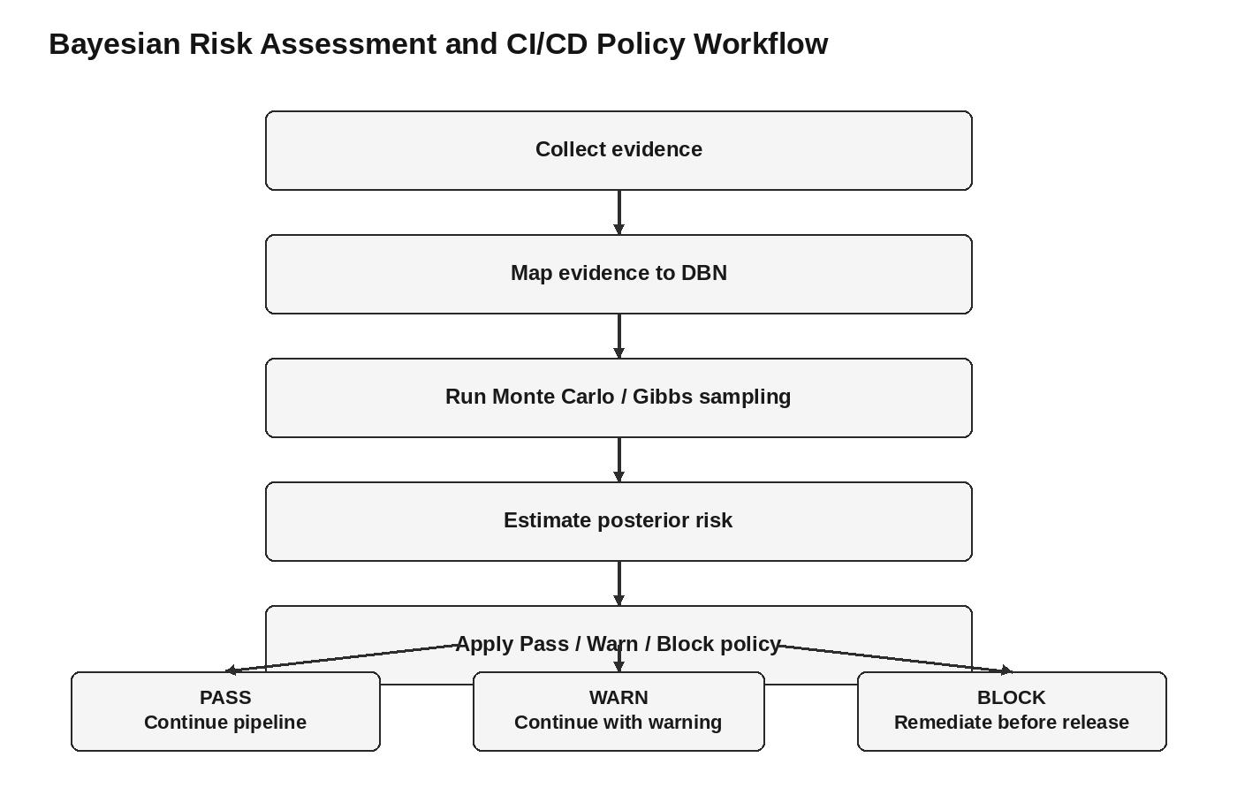
Figure 4.1: Bayesian risk assessment and CI/CD policy workflow.
4.4 Mathematical Modelling Procedure

The project identifies joint probability and temporal transition equations as part of its DBN design. Because the mathematical expressions are not fully preserved in the extracted presentation text, this report does not reconstruct missing equation symbols. Instead, the implementation procedure is documented according to the explicitly stated algorithmic sequence: causal-node construction, joint-probability modelling, temporal transition modelling, evidence instantiation, iterative sampling and policy decision.

4.5 Pipeline Policy Implementation

Policy State | Implementation Action | Expected Outcome
Pass | Continue CI/CD execution | Software progresses to the next pipeline stage.
Warn | Continue execution and generate warning | Development continues with elevated security awareness.
Block | Stop pipeline execution | Remediation is required before continuation.
Table 4.2 Pipeline policy decisions.

4.6 Supplied Modelling Dataset

The project presentation provides a sample dataset for analysis. The records contain attack type, risk score, risk level, normalized CVSS score, Bayesian posterior and Bayesian risk level. The values below are reproduced from the supplied presentation.
Attack Type | Risk Score | Risk Level | CVSS Score Normalized | Bayesian Posterior | Bayesian Risk Level
Typosquatting | 0.445 | Medium | 0.5555555555555556 | 0.2668 | Low
Malicious Package | 0.518 | Medium | 0.696969696969697 | 0.3106 | Medium
Typosquatting | 0.387 | Medium | 0.9191919191919191 | 0.2322 | Low
Dependency Confusion | 0.629 | High | 0.6161616161616162 | 0.3776 | Medium
Dependency Confusion | 0.305 | Medium | 0.4242424242424243 | 0.1832 | Low
Table 4.3 Supplied modelling dataset.

4.7 Analysis of the Modelling Data

The supplied dataset demonstrates that the Bayesian posterior does not simply reproduce the original risk score. For example, the dependency-confusion record with an original risk score of 0.629 is labelled High, while its Bayesian posterior is 0.3776 and the resulting Bayesian risk level is Medium. Similarly, the typosquatting records are classified as Low after Bayesian updating even though their initial risk levels are Medium.

The dataset therefore illustrates the intended role of Bayesian updating: observed evidence is incorporated into a probabilistic model, producing a revised risk estimate. The project presentation states that components with higher frequencies of observed vulnerabilities generally produce higher posterior risk estimates and that posterior estimates can become more stable as additional observations are incorporated.

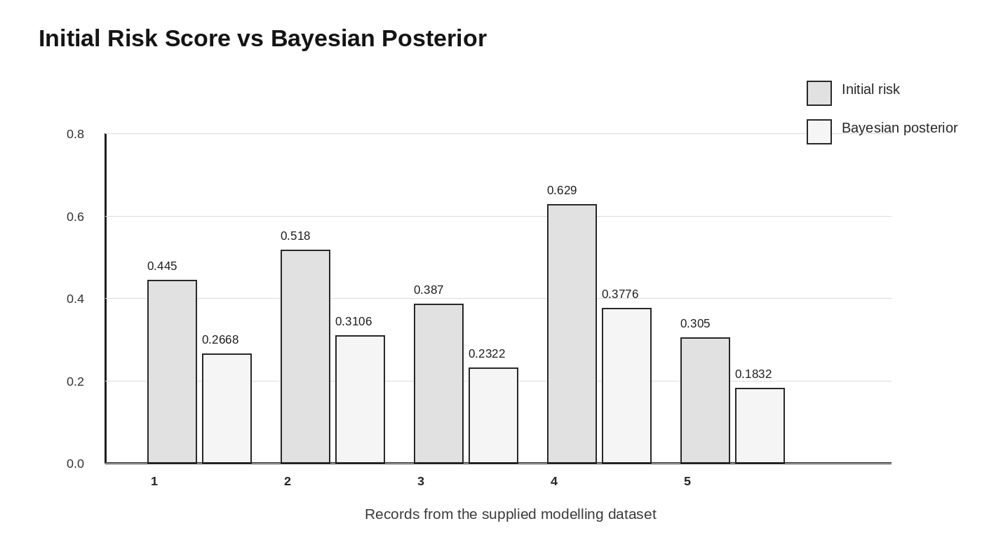
Figure 4.2: Comparison of initial risk scores and Bayesian posterior values.

4.8 Bayesian Risk Assessment and DevSecOps Mapping

Bayesian Risk Assessment | DevSecOps Security | Equivalent Meaning
Prior Probability | Baseline Security Risk | Initial belief about the possibility of compromise.
Vulnerability Evidence | SAST / SCA Findings | Observed security weaknesses.
Posterior Probability | Updated Risk Assessment | Risk after incorporating new evidence.
Impact | Business / System Impact | Potential consequence of compromise.
Evidence Accumulation | Continuous CI/CD Monitoring | Repeated observations over the development lifecycle.
Risk Score | Security Prioritization | Quantitative basis for deciding which risk deserves attention.
Table 4.4 Interpretation of Bayesian and DevSecOps factors.

4.9 Comparison and Visualization

The presentation includes comparison plots, a heatmap for the ABM-SD model, and a visualization describing the evolution of Bayesian Dynamic Network simulation. These visual elements are intended to show differences in risk exposure and changes in modelled risk across simulated components or states. The report treats these visuals as supporting evidence for the conceptual analysis rather than assigning numerical performance values that are not explicitly provided.

4.10 Verification Against Project Objectives

Objective | Evidence Available in PPT | Status
Construct DBN causal model | Causal nodes for evidence, vulnerabilities, threats and impact are described. | Demonstrated in methodology
Develop Monte Carlo simulation | Monte Carlo and Gibbs sampling are described as the simulation approach. | Demonstrated in methodology
Integrate CI/CD telemetry | Ingestion layer identifies Git, SAST/SCA and Cosign/build-signing evidence. | Proposed / described
Verify and benchmark risk assessment | Sample modelling data and comparative discussion are supplied. | Partially evidenced; full benchmark protocol not supplied
Table 4.5 Objective-wise verification.

4.11 Strengths

- Represents security risk probabilistically rather than only as a deterministic score.
- Models evolving conditions through Dynamic Bayesian Network temporal transitions.
- Supports cascading and dependency-aware reasoning.
- Combines multiple evidence types from DevSecOps tooling.
- Uses Monte Carlo and Gibbs sampling for complex dependency structures.
- Connects risk estimation to actionable CI/CD Pass, Warn and Block decisions.
- Provides a mitigation-oriented decision path for blocked builds.

4.12 Limitations of the Available Results

- The presentation provides only a sample modelling dataset rather than a complete experimental dataset.
- The extracted presentation does not preserve all mathematical symbols in the numbered equations.
- A complete software repository or source-code listing is not supplied in the presentation material.
- The benchmark methodology and test-set composition are not fully described.
- The presentation refers to accuracy and false-positive reduction concepts, but a complete statistical evaluation protocol is not provided in the supplied content.

4.13 Project Management and Roles

The project presentation identifies the four team members but does not state a verified role allocation for each individual. The final submitted report should therefore use the table below only after the team confirms the actual responsibilities.

Student | Proposed Role Field | Verified Contribution
Ponmudi B (192465053) | [To be completed] | [To be verified]
Mohamed Irfan N (192521473) | [To be completed] | [To be verified]
Vickramabharathi V (192465069) | [To be completed] | [To be verified]
Abinesh M (192465050) | [To be completed] | [To be verified]
Table 4.6 Project roles.

4.14 Discussion

The project demonstrates the central value of probabilistic risk modelling in a software supply-chain context. A software component does not exist in isolation: its security state can be influenced by its dependency relationships, observed vulnerabilities, build environment and accumulated evidence. A Dynamic Bayesian Network provides a structure for representing these relationships while preserving uncertainty.
The modelling dataset also illustrates why posterior risk can differ from an initial score. A security observation can increase or decrease the estimated risk depending on the prior belief and the relationships encoded in the network. This is useful for DevSecOps because a pipeline decision can then be based on a broader evidence context rather than one isolated scanner value.
At the same time, the effectiveness of the framework depends strongly on the quality of the model. Incorrect causal relationships, incomplete evidence or poorly calibrated probabilities can lead to inappropriate Pass, Warn or Block decisions. Therefore, SupplyShield should be considered a decision-support framework that requires validation before automated production enforcement.

4.15 Chapter Summary

This chapter described the implementation architecture, algorithmic workflow, supplied modelling dataset, Bayesian-to-DevSecOps mapping, policy decisions, verification and limitations. The results support the project's central claim that Bayesian simulation can provide a dynamic and evidence-based representation of software supply-chain risk.

CHAPTER 5

CONCLUSION, FUTURE WORK AND REFLECTION

  - Conclusion

SupplyShield presents a Dynamic Bayesian Network and simulation-based approach for assessing software supply-chain risk in DevSecOps environments. The project is motivated by the limitations of static, point-in-time scanning and deterministic risk scoring, particularly when software dependencies evolve and vulnerability information is incomplete.
The proposed framework combines an ingestion layer, a Bayesian inference engine, a Monte Carlo simulation engine and a CI/CD policy gate. Evidence from source control, SAST/SCA scanners and build-signing mechanisms can be mapped to causal nodes representing evidence, vulnerabilities, threats and impact. Temporal transitions allow the model to represent changes across pipeline runs, while Gibbs sampling provides an approximation mechanism for dense dependency structures.
The supplied modelling dataset demonstrates the intended effect of Bayesian updating. Initial risk scores and normalized CVSS evidence are transformed into posterior risk values and Bayesian risk levels. This supports the project's argument that risk can be interpreted using a broader probabilistic context rather than relying on a single deterministic value.
Overall, the project provides a practical conceptual framework for dynamic, evidence-based software supply-chain security. It connects probabilistic modelling with operational DevSecOps decisions and provides a foundation for future real-world integration.
  - Future Work

Future Scope | Planned Enhancement
Real-world data integration | Integrate live CVE feeds, SBOM data, dependency scanners, SAST/SCA findings and CI/CD security logs.
Advanced predictive modelling | Combine Bayesian networks, machine learning and time-series analysis to identify emerging supply-chain threats.
Automated DevSecOps integration | Integrate with CI/CD pipelines, SLSA provenance and automated security gates.
Automated remediation | Extend the policy layer so that identified high-impact variables can trigger or recommend remediation actions.
Table 5.1 Future work and planned enhancements.

  - Professional Learning & Individual Reflection

5.3.1 New Knowledge Acquired
The project provides exposure to probabilistic modelling, software supply-chain security, DevSecOps practices, Dynamic Bayesian Networks, Monte Carlo simulation and MCMC methods. It also demonstrates how mathematical risk modelling can be connected to practical CI/CD decisions.
- Understanding of software supply-chain risk and dependency-based threats.
- Understanding of Bayesian prior and posterior reasoning.
- Exposure to Dynamic Bayesian Network concepts and temporal transitions.
- Understanding of Monte Carlo simulation and Gibbs sampling.
- Understanding of CI/CD security gates and risk-based decision support.
- Experience interpreting modelled security-risk data and comparative visualizations.

5.3.2 Engineering & Professional Skills Developed
- Problem formulation and engineering gap identification.
- Probabilistic and mathematical modelling.
- Security-risk interpretation.
- System architecture and modular design thinking.
- Data analysis and result interpretation.
- Technical documentation and presentation.
- Critical evaluation of assumptions, limitations and future improvements.

5.3.3 Individual Reflection
Vickramabharathi V (192465069)
Role: Attack Simulation Engine. Focused on modular DDoS, Port Scan and Brute Force simulation, including traffic generation and attack-specific behaviour. The project work required modular engineering decisions, testing of the corresponding subsystem and integration with the complete detection-and-response pipeline.

Ram Prasath J (192565021)
Role: Detection Rule Engine. Focused on weighted detection logic and transparent real-time threat scoring. The project work required modular engineering decisions, testing of the corresponding subsystem and integration with the complete detection-and-response pipeline.

Abinesh M (192465050)
Role: Real-Time Pipeline. Focused on Socket.IO broadcasting and end-to-end latency testing. The project work required modular engineering decisions, testing of the corresponding subsystem and integration with the complete detection-and-response pipeline.

Dhanushkumar R (192565087)
Role: SQLite Repository Layer. Focused on SQLite persistence and the nine-repository backend layer. The project work required modular engineering decisions, testing of the corresponding subsystem and integration with the complete detection-and-response pipeline.

REFERENCES
[1] M. Wang, Q. Luo, P. Wu, and H. Zheng, “MMEF-SSCT: A novel multidimensional and multi-level comprehensive evaluation framework for software supply chain threats,” Expert Systems with Applications, vol. 296, Art. no. 128924, Jan. 2026.
[2] S. Hamer, J. Bowen, M. N. Haque, R. Hines, C. Madden, and L. Williams, “Closing the Chain: How to Reduce Your Risk of Being SolarWinds, Log4j, or XZ Utils,” in Proc. IEEE/ACM International Conference on Software Engineering (ICSE), Apr. 2026.
[3] G. Tystahl, J. Ghebremichael, S. Muralee, S. Cherupattamoolayil, A. Bianchi, A. Machiry, A. Kapravelos, and W. Enck, “Cosseter: GitHub Actions Permission Reduction Using Demand-Driven Static Analysis,” in Proc. IEEE Symposium on Security and Privacy (S&P), May 2026.
[4] I. Rahman, J. Marley, W. Enck, and L. Williams, “Which Is Better for Reducing Outdated and Vulnerable Dependencies: Pinning or Floating?,” in Proc. IEEE/ACM International Conference on Automated Software Engineering (ASE), Nov. 2025.
[5] H. He, B. Vasilescu, and C. Kästner, “Pinning Is Futile: You Need More Than Local Dependency Versioning to Defend Against Supply Chain Attacks,” in Proc. ACM SIGSOFT International Symposium on the Foundations of Software Engineering (FSE), Jun. 2025.
[6] N. Zahan, P. Burckhardt, M. Lysenko, F. Aboukhadijeh, and L. Williams, “Leveraging Large Language Models to Detect npm Malicious Packages,” in Proc. IEEE/ACM International Conference on Software Engineering (ICSE), Apr. 2025.
[7] L. Williams et al., “Research Directions in Software Supply Chain Security,” ACM Transactions on Software Engineering and Methodology, Jan. 2025.
[8] J.-U. Holtgrave et al., “Attributing Open-Source Contributions is Critical but Difficult: A Systematic Analysis of GitHub Practices and Their Impact on Software Supply Chain Security,” Feb. 2025.
[9] R. Chandramouli, F. Kautz, and S. Torres-Arias, “Strategies for the Integration of Software Supply Chain Security in DevSecOps CI/CD Pipelines,” NIST Special Publication 800-204D,.
[10] L. Williams, “Narrowing the Software Supply Chain Attack Vectors: The SSDF Is Wonderful but Not Enough,” IEEE Security & Privacy, vol. 22, no. 2, pp. 4–7, Mar. 2024.
[11] L. Boughton, C. Miller, Y. Acar, D. Wermke, and C. Kästner, “Decomposing and Measuring Trust in Open-Source Software Supply Chains,” in Proc. IEEE/ACM International Conference on Software Engineering, New Ideas and Emerging Results (ICSE-NIER), Apr. 2024.
[12] J. Y. Zhang and Y. Zhang, “Quantitative DevSecOps Metrics for Cloud-Based Web Microservices,” IEEE Access, vol. 12, pp. 160317–160342, 2024.
[13] F. Massacci and L. Williams, “Software Supply Chain Security,” IEEE Security & Privacy, vol. 21, no. 6, pp. 8–10, Nov./Dec. 2023.
[14] N. Zahan, E. Lin, M. Tamanna, W. Enck, and L. Williams, “Software Bills of Materials Are Required. Are We There Yet?,” IEEE Security & Privacy, vol. 21, no. 2, pp. 82–88, Apr. 2023.
[15] A. F. H. Librantz, I. Costa, M. de M. Spinola, G. C. de Oliveira Neto, and L. Zerbinatti, “Risk assessment in software supply chains using the Bayesian method,” International Journal of Production Research, vol. 59, no. 22, pp. 6758–6775, 2021.
[16] K. Scarfone, M. Souppaya, and D. Dodson, “Secure Software Development Framework (SSDF) Version 1.1: Recommendations for Mitigating the Risk of Software Vulnerabilities,” NIST Special Publication 800-218, Feb. 2022.

APPENDICES

APPENDIX A – BAYESIAN MODEL AND CALCULATION PROCEDURE
A.1 Model Calculation Stages
Stage | Calculation / Processing Activity | Purpose
1 | Define causal nodes | Represent evidence, vulnerabilities, threats and impact.
2 | Model joint probability relationships | Represent how connected variables influence overall risk.
3 | Apply temporal transitions | Represent changes between consecutive pipeline runs.
4 | Instantiate observed evidence | Fix observed nodes to scanner-derived states.
5 | Run Gibbs sampling | Approximate the posterior distribution of unobserved variables.
6 | Apply policy gate | Convert risk assessment into Pass, Warn or Block.
Table A.1 Bayesian model calculation stages.

The supplied presentation contains numbered equations for the joint probability, temporal transition and Gibbs-sampling stages, but the extraction does not preserve all mathematical symbols. The final report should reproduce the original equations directly from the presentation or project source if exact mathematical notation is required.

APPENDIX B – ENGINEERING DRAWINGS / SCHEMATICS
The following textual schematic represents the architecture described in the project presentation.
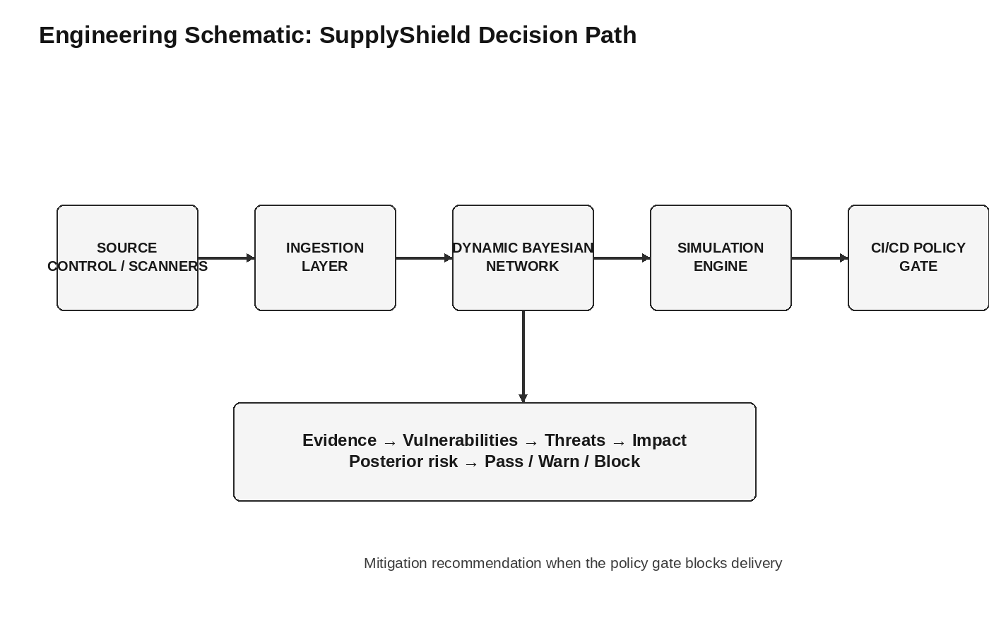
Figure B.1: Engineering schematic of the SupplyShield decision path.
Component | Function
Ingestion Layer | Collects pipeline and security evidence.
Inference Engine | Maps evidence to DBN causal nodes.
Simulation Engine | Approximates risk using Monte Carlo/Gibbs sampling.
Policy Gate | Applies Pass, Warn and Block decisions.
Mitigation Logic | Identifies a high-impact variable change for risk reduction when a build is blocked.
Table B.1 System schematic components.

APPENDIX C – SOURCE CODE / CODE REPOSITORY INFORMATION
The supplied presentation describes the algorithmic workflow but does not provide a complete source-code listing or repository URL. The final report should attach or reference the actual project repository if one exists.
C.1 Essential Algorithmic Pseudocode
collect_evidence()
map_evidence_to_dbn()
initialize_unobserved_nodes()
for each simulation step:
sample_unobserved_nodes_using_conditional_probabilities()
estimate_posterior_risk()
apply_pass_warn_block_policy()
if blocked:
identify_highest_risk_reduction_change()
C.2 Repository Information
Item | Information
Project title | SupplyShield: Bayesian Simulation of Software Supply Chain Risk in DevSecOps
Primary modelling approach | Dynamic Bayesian Network
Simulation approach | Monte Carlo with Gibbs sampling / MCMC
Complete source code | Not supplied in the presentation
Repository URL | Not supplied in the presentation
Table C.1 Repository and source-code information.

APPENDIX D – DATASHEETS
This project is a software modelling and simulation project. The supplied presentation does not identify physical hardware, electronic components or manufacturer datasheets.
Item | Datasheet Requirement | Status
Hardware components | Manufacturer datasheets | Not applicable
Electronic components | Technical datasheets | Not applicable
Software/model | Technical model description | Covered in Chapters 3 and 4 and Appendix A
Table D.1 Datasheet applicability status.

APPENDIX E – EXPERIMENTAL / RAW DATA
The supplied presentation includes a sample modelling dataset. It does not provide a complete raw-data collection procedure, full time-series dataset, complete dependency graph or complete benchmark dataset.
Attack Type | Risk Score | Risk Level | CVSS Normalized | Bayesian Posterior | Bayesian Risk Level
Typosquatting | 0.445 | Medium | 0.5555555555555556 | 0.2668 | Low
Malicious Package | 0.518 | Medium | 0.696969696969697 | 0.3106 | Medium
Typosquatting | 0.387 | Medium | 0.9191919191919191 | 0.2322 | Low
Dependency Confusion | 0.629 | High | 0.6161616161616162 | 0.3776 | Medium
Dependency Confusion | 0.305 | Medium | 0.4242424242424243 | 0.1832 | Low
Table E.1 Available raw modelling data.

APPENDIX F – ETHICS / INSTITUTIONAL APPROVAL
The supplied project presentation does not report human-subject research, personal-data collection, animal experimentation, field trials, or institutional ethics approval. The project is presented as a software supply-chain risk modelling and simulation study.
If future experiments use private repositories, developer identities, internal CI/CD logs, proprietary package information or other sensitive data, the team should obtain the required institutional and organizational approvals and apply appropriate security and privacy controls.
Approval status: No ethics or institutional approval document is included in the supplied project presentation.

